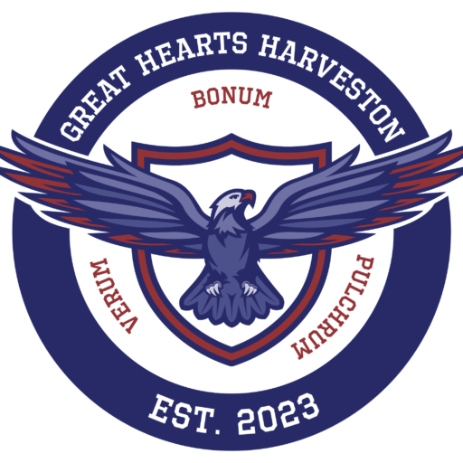

PSO Information Meeting Agenda
Tuesday, August 12, 2025
7:00 PM | Great Hearts Harveston Cafeteria

1. Welcome & PSO Board Introductions
- Laura Metcalf, President
- Sally McBride, Vice President
- Teryn Bryant, Secretary
- Laura Faucheux, Treasurer

2. What is the Parent Service Organization (PSO)?
The PSO plays a vital role in fostering a close-knit community and a warm, welcoming culture for GHH students and their families. Volunteer opportunities include:
- Room Parent
- Committee Member (events, teacher appreciation, etc.)
- Men’s Club
- Lunchroom Volunteer (Mondays & Fridays)
- Reading Group Volunteer
The PSO also supports teachers with classroom needs and curriculum-related activities.

3. How Do I Join the PSO?
All parents with a child enrolled at GHH are automatically members.
To volunteer on campus during the school day, complete a background check:
➡️ Scan here to complete a background check

To receive PSO email updates and event reminders:
➡️ Scan here to join the PSO email list


4. How is the PSO Funded?
• The PSO does not solicit direct donations.
• GHH receives charitable support through Community Investment.
• PSO is funded through passive income sources: Spirit Shirt sales, ticket sales, bake sales, etc.
For donations to the school:
📧 Carley Hopkins at carley.hopkins@greathearts.org

5. Introduction of Room Parent Liaisons & Room Parent Responsibilities
Room Parent Liaisons:
- K–5: June Davis
- 6–9: Jamie Hawley
- SSC: Alena Gomes
Room Parent Responsibilities:
- Facilitate classroom celebrations
- Coordinate field trips
- Ensure classroom needs are met
- Celebrate teacher birthdays
Planned Celebrations:
- Storybook Fest – Friday, October 31
- Winter Celebration – Friday, December 19
- Mardi Gras Celebration/Great Hearts Day – Friday, February 13
- Spring Celebration – Thursday, April 9

➡️ Scan here to express interest in being a Room Parent

6. PSO Committees
Available Committees:
- Teacher Appreciation – Janee Chanet
- Men’s Club
- Community Events – Chair Position Open
- Lunch Room Parents – Chair Position Open
➡️ Scan here to join a committee


7. Community Events (2025–2026)
- *Tentative* Art Stroll – Fall TBD
- Grandparent’s/Special Person’s Day – Wednesday, October 15
- Fall Fest – Friday, November 7
- GLOW Night (Mother/Son Night or Special Person) – Friday, January 9
- Gingerbread Pancake Breakfast – Saturday, December 13
- Winter Wonderland (Father/Daughter Dance or Special Person) – Friday, January 23
- Pi Day Celebration – Friday, March 13
- Spring Social (Family Picnic) – Saturday, April 18

8. Spirit Shirts
Spirit Shirt sales help fund PSO activities. Designated Spirit Shirt Days occur throughout the year. The deadline is Friday, August 22 to get a shirt for the Fall.

➡️ Scan here to order a Spirit Shirt

9. Q&A

Please join us at our upcoming planning meetings:
Fall – Tuesday, September 9 at 7:00 PM in the Great Hearts Harveston Cafeteria
Spring – Tuesday, January 13 at 7:00 PM in the Great Hearts Harveston Cafeteria

If you have feedback, questions, suggestions, or concerns, please contact us:
pso@greatheartsharveston.org

